AZURE DEVOPS

AZURE Devops :

* Azure DevOps is a suite of Microsoft's cloud-based services and tools that supports the entire software development lifecycle (SDLC), from planning and code development to deployment and monitoring.
* It enables collaboration between development and operations teams, providing continuous integration and continuous delivery (CI/CD) functionality.

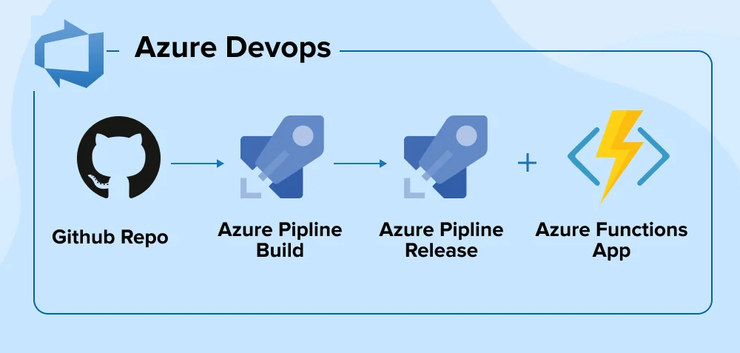

Azure DevOps offers two main versions:

* Azure DevOps Services: A Software-as-a-Service (SaaS) platform hosted in the cloud and managed by Microsoft.
* Azure DevOps Server: An on-premises version that gives organizations complete control over their data, requiring local server maintenance.

Core services :

The platform is composed of five key services that can be used together or independently:

* Azure Boards: Agile planning tools for tracking work items, including user stories, bugs, features, and tasks, using Scrum or Kanban boards.
* 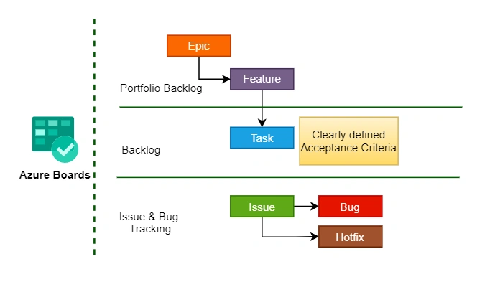
* Azure Repos: Provides version control with unlimited, cloud-hosted private Git repositories or the older Team Foundation Version Control (TFVC).
* Azure Pipelines: A CI/CD service that automatically builds, tests, and deploys code to any platform or cloud environment, including Azure, AWS, and Google Cloud.
* 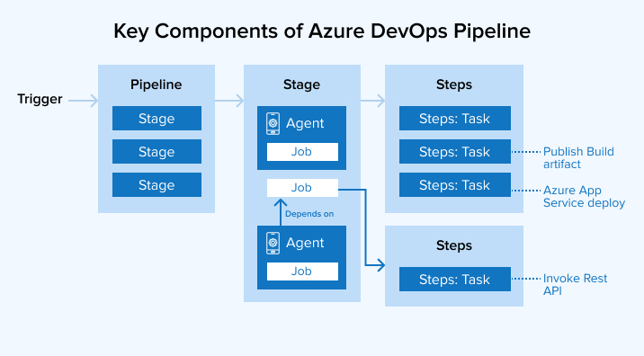
* Azure Test Plans: A comprehensive tool for manual and automated testing, allowing teams to plan, execute, and track test runs.
* Azure Artifacts: A package management service that allows teams to create, host, and share packages like NuGet, npm, and Maven.